Constructing Angle

Definition
# Source: AI Source: Provided by: [Data Path: Persons Table -> ID Column: 1, Name_En Column: Motasem Essam] -> From: [ChatGPT] on [7/25/2026]
Constructing an angle is a geometric construction in which an angle of a specified measure, or an angle equal to a given angle, is created using exact geometric methods.
An angle is formed by two rays that share a common endpoint called the vertex.
For an angle with vertex $B$:
$$\boxed{∠ABC}$$
where:
- $B$is the vertex.
- $\vec{BA}$and $\vec{BC}$are the sides of the angle.
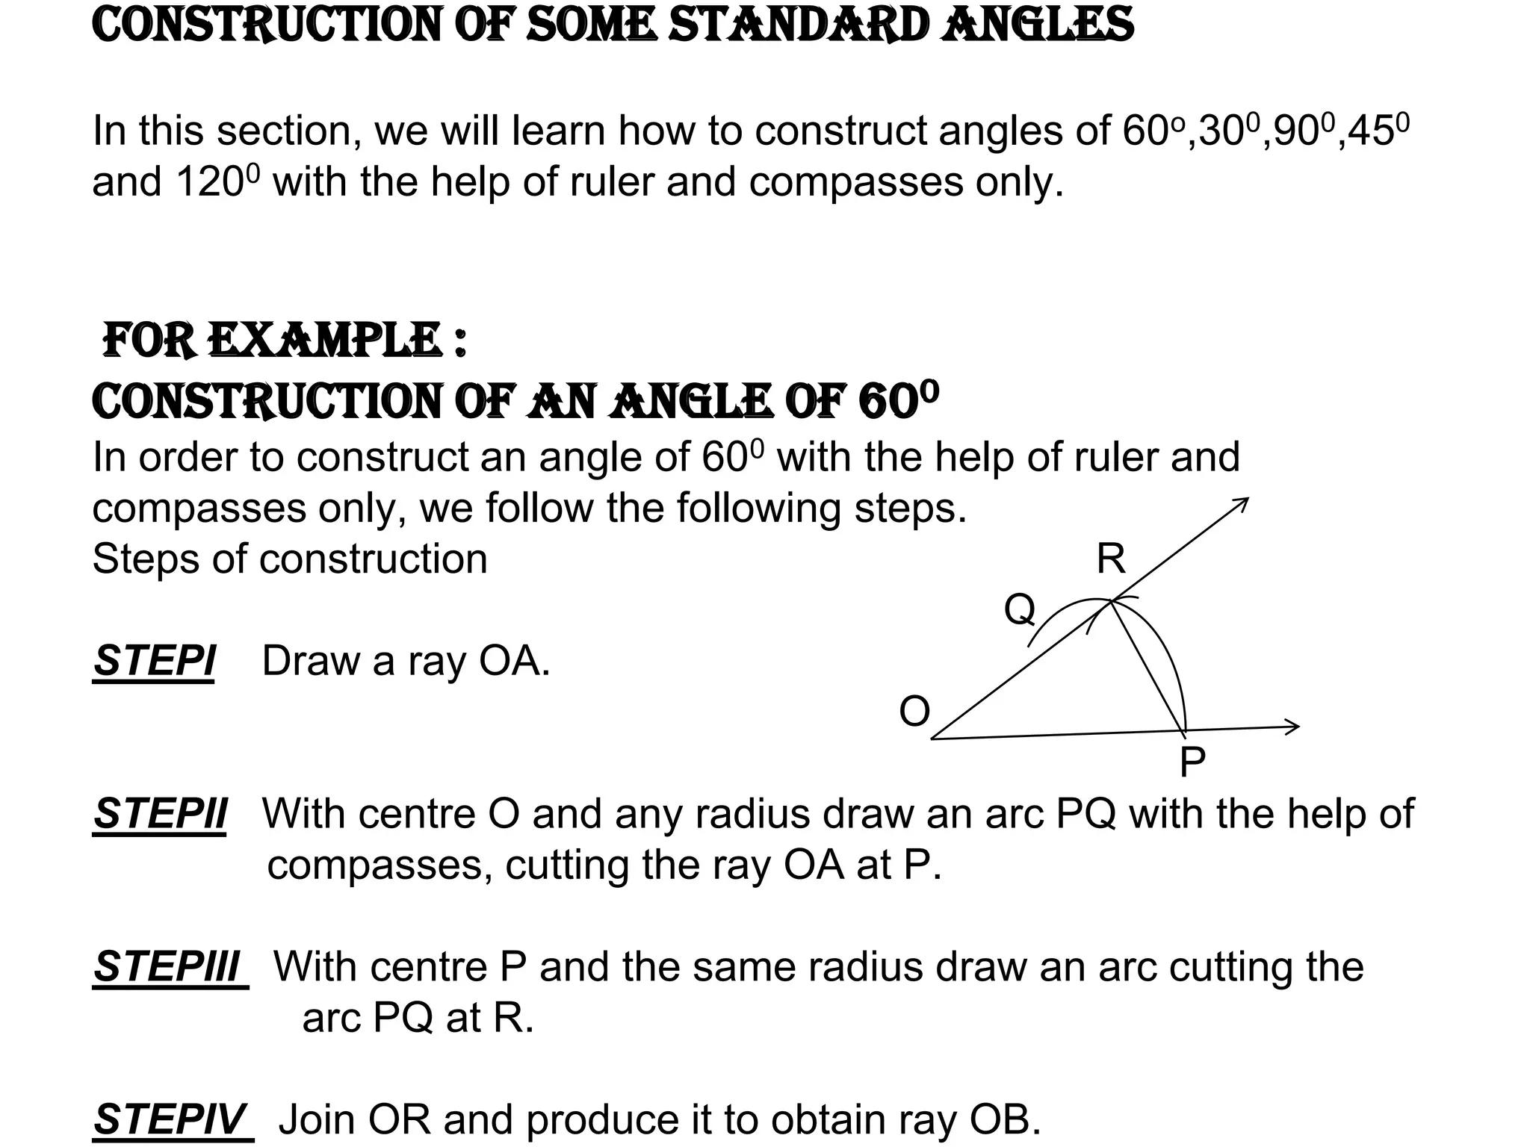
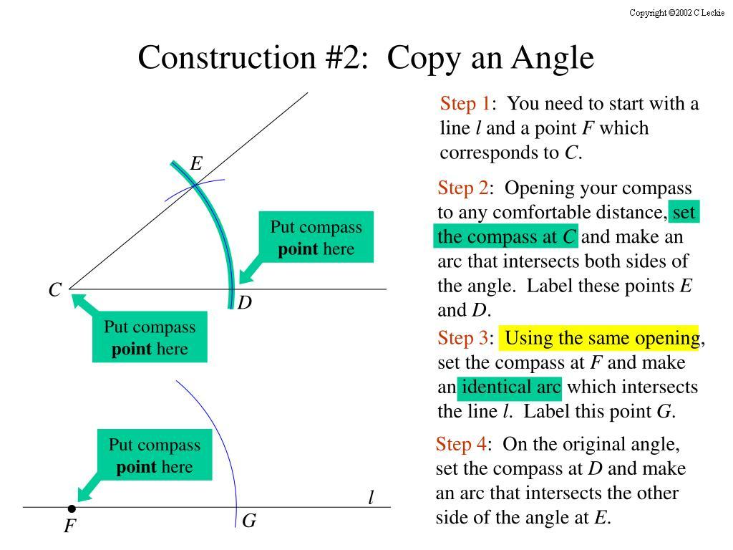
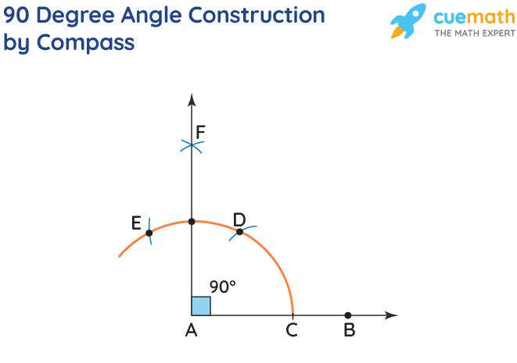
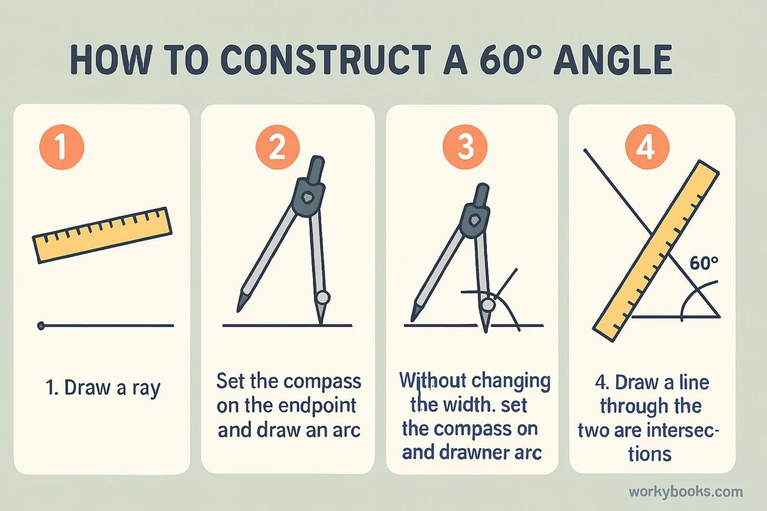
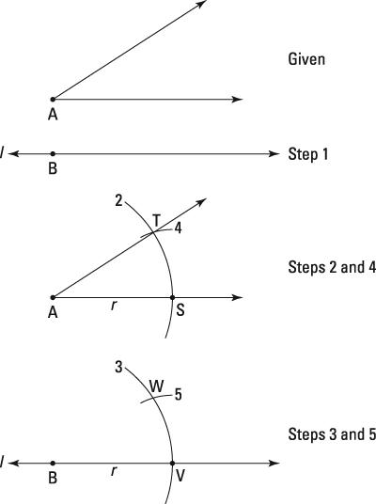
Fundamental Concept
An angle can be constructed in several ways depending on the information provided.
The main situations are:
- Constructing an angle of a given measure
- Copying a given angle
- Constructing a special angle
- Constructing an angle by combining other constructed angles
- Bisecting a given angle
In classical Euclidean construction, the primary tools are the straightedge and compass.

1. Constructing an Angle of a Given Measure
# Source: AI Source: Provided by: [Data Path: Persons Table -> ID Column: 1, Name_En Column: Motasem Essam] -> From: [ChatGPT] on [7/25/2026]
Suppose an angle of measure $θ$is required.
For example:
$$\boxed{θ={60}^{∘}}$$
A compass and straightedge can be used to construct the angle exactly.
The resulting angle satisfies:
$$\boxed{∠ABC={60}^{∘}}$$
General Construction Idea
- Construct a starting ray $\vec{BA}$.
- Use the compass to establish an appropriate arc or geometric relationship.
- Construct the second ray $\vec{BC}$.
- The two rays form the required angle.
The exact construction procedure depends on the particular angle.

2. Copying a Given Angle
# Source: AI Source: Provided by: [Data Path: Persons Table -> ID Column: 1, Name_En Column: Motasem Essam] -> From: [ChatGPT] on [7/25/2026]
Copying an angle means constructing an angle that has exactly the same measure as a given angle.
Suppose:
$$∠ABC$$
is given.
The goal is to construct:
$$∠DEF$$
such that:
$$\boxed{∠DEF=∠ABC}$$
Construction Steps
- Draw a ray $\vec{DE}$.
- With the compass centered at $B$, draw an arc intersecting $BA$and $BC$.
- Keep the same compass opening and draw an arc centered at $E$.
- Measure the distance between the two intersection points on the original arc.
- Transfer that distance to the new arc.
- Draw the second ray through the transferred point.
Therefore:
$$\boxed{∠DEF=∠ABC}$$
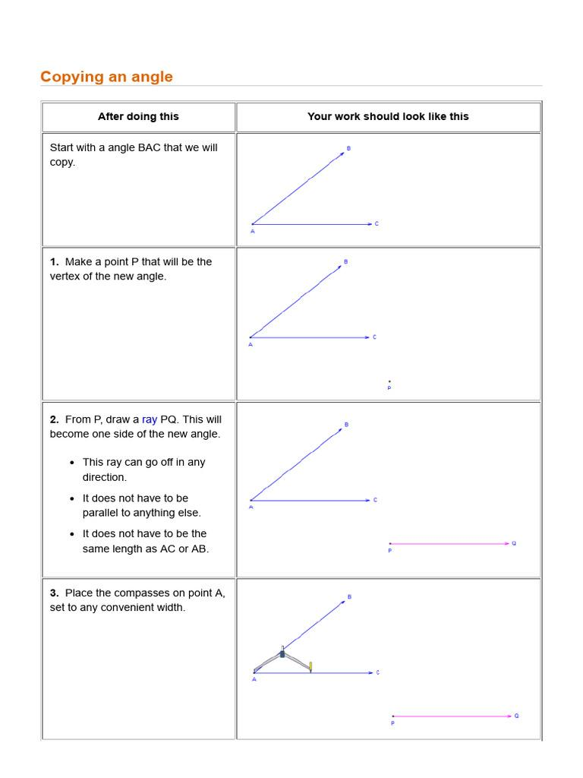
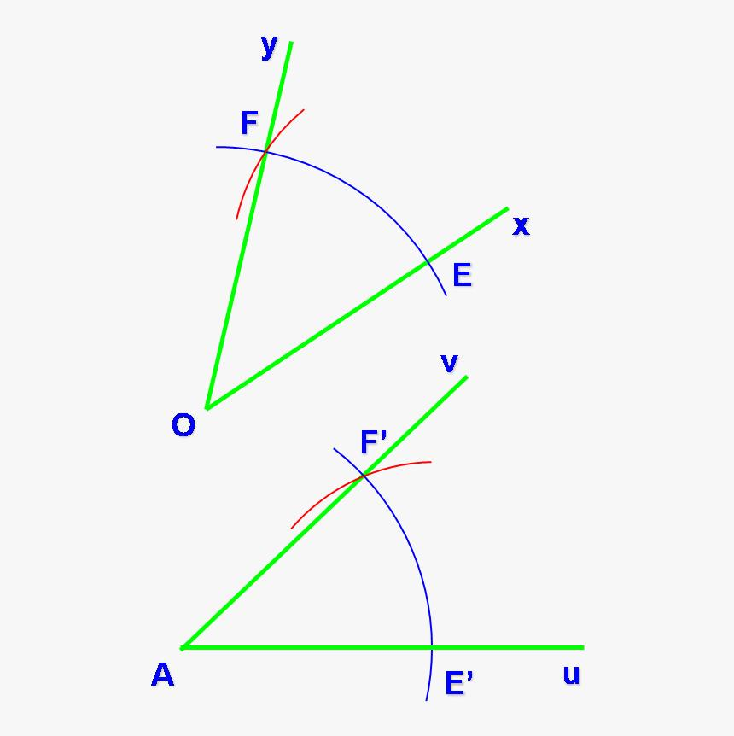
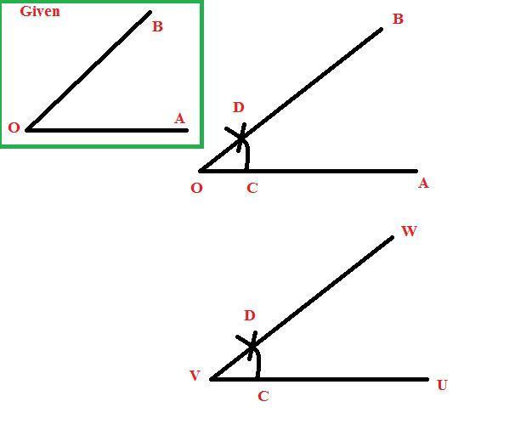

3. Constructing a ${60}^{∘}$Angle
# Source: AI Source: Provided by: [Data Path: Persons Table -> ID Column: 1, Name_En Column: Motasem Essam] -> From: [ChatGPT] on [7/25/2026]
A ${60}^{∘}$angle can be constructed using an equilateral triangle.
Construction Steps
- Draw a ray $\vec{AB}$.
- With center $A$, draw an arc with radius $AB$.
- With center $B$, using the same radius, draw another arc.
- Let the arcs intersect at $C$.
- Draw $\vec{AC}$.
Since:
$$AB=AC=BC$$
triangle $ABC$is equilateral.
Therefore:
$$\boxed{∠BAC={60}^{∘}}$$

4. Constructing a ${90}^{∘}$Angle
# Source: AI Source: Provided by: [Data Path: Persons Table -> ID Column: 1, Name_En Column: Motasem Essam] -> From: [ChatGPT] on [7/25/2026]
A ${90}^{∘}$angle can be constructed by constructing a perpendicular line.
If:
$$l_{1}⊥l_{2}$$
then:
$$\boxed{∠={90}^{∘}}$$
Construction Idea
- Draw a line or ray.
- Mark a point where the perpendicular is required.
- Use equal-radius arcs to establish two points on the original line.
- Construct the perpendicular bisector of those points.
- The resulting line forms a ${90}^{∘}$angle with the original line.
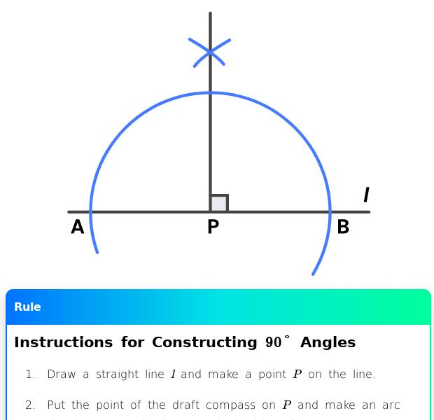
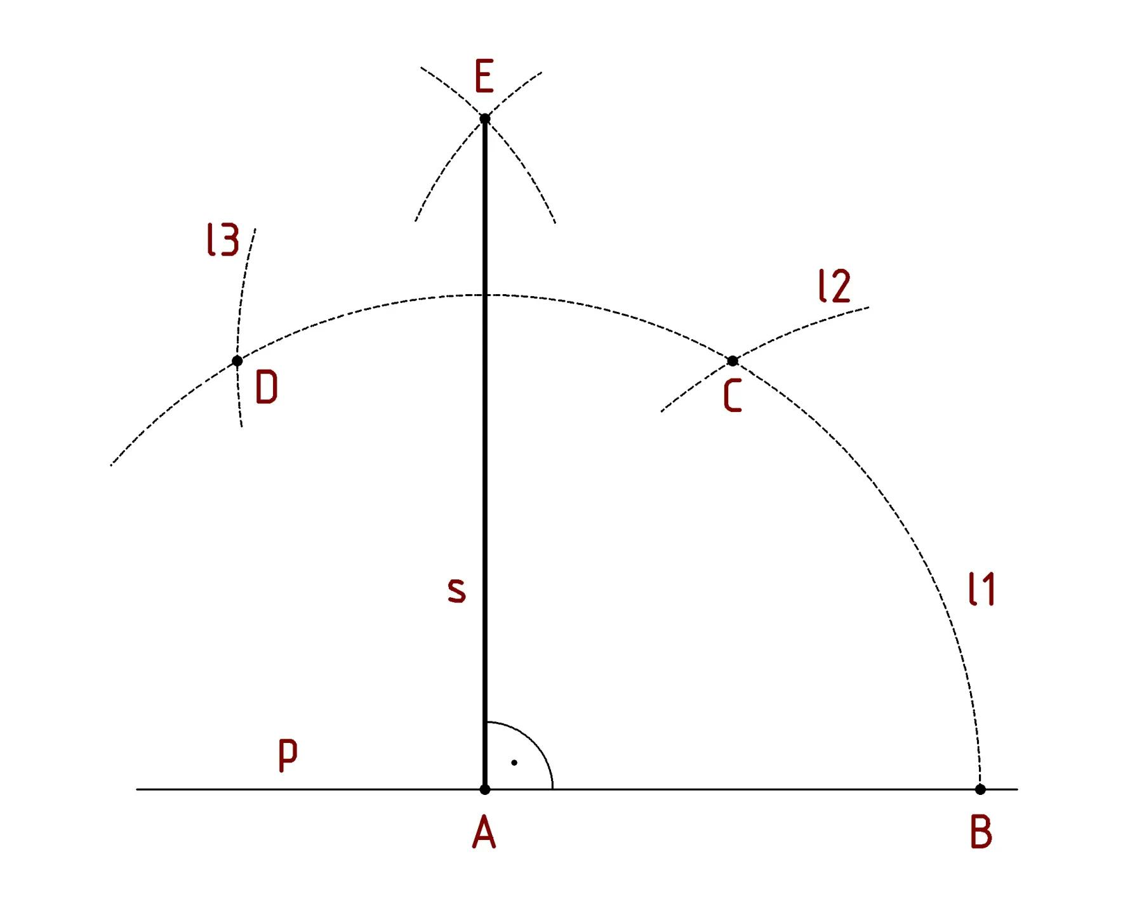
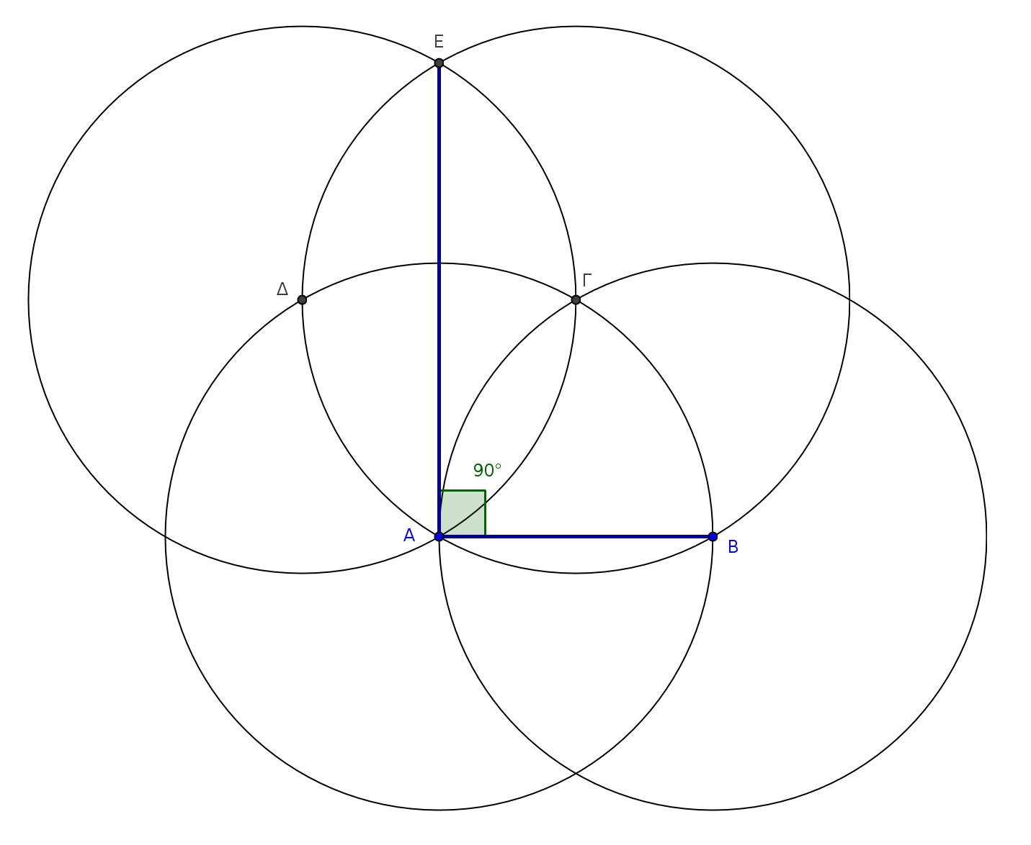
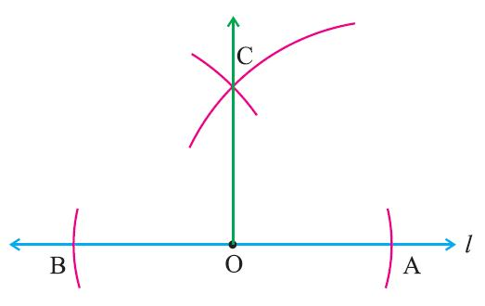
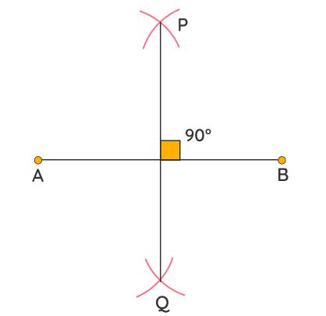

5. Constructing a ${30}^{∘}$Angle
# Source: AI Source: Provided by: [Data Path: Persons Table -> ID Column: 1, Name_En Column: Motasem Essam] -> From: [ChatGPT] on [7/25/2026]
A ${30}^{∘}$angle can be constructed by bisecting a ${60}^{∘}$angle.
First construct:
$${60}^{∘}$$
Then construct its angle bisector:
$$\frac{{60}^{∘}}{2}={30}^{∘}$$
Therefore:
$$\boxed{{30}^{∘}}$$

6. Constructing a ${45}^{∘}$Angle
# Source: AI Source: Provided by: [Data Path: Persons Table -> ID Column: 1, Name_En Column: Motasem Essam] -> From: [ChatGPT] on [7/25/2026]
A ${45}^{∘}$angle can be constructed by bisecting a ${90}^{∘}$angle.
First construct:
$${90}^{∘}$$
Then bisect it:
$$\frac{{90}^{∘}}{2}={45}^{∘}$$
Therefore:
$$\boxed{{45}^{∘}}$$

7. Constructing Other Angles
# Source: AI Source: Provided by: [Data Path: Persons Table -> ID Column: 1, Name_En Column: Motasem Essam] -> From: [ChatGPT] on [7/25/2026]
Other constructible angles can be obtained by combining, subtracting, or bisecting already constructed angles.
For example:
$${60}^{∘}-{30}^{∘}={30}^{∘} \\ {90}^{∘}-{60}^{∘}={30}^{∘} \\ {90}^{∘}+{45}^{∘}={135}^{∘}$$
and:
$$\frac{{90}^{∘}}{2}={45}^{∘}$$
Repeated angle bisection can produce:
$${45}^{∘}, {22.5}^{∘}, {11.25}^{∘},…$$
provided the required construction sequence is continued.

8. Bisecting an Angle
# Source: AI Source: Provided by: [Data Path: Persons Table -> ID Column: 1, Name_En Column: Motasem Essam] -> From: [ChatGPT] on [7/25/2026]
Angle bisection is a related construction in which a given angle is divided into two equal angles.
For:
$$∠ABC$$
construct a ray:
$$\vec{BD}$$
such that:
$$\boxed{∠ABD=∠DBC}$$
Therefore:
$$\boxed{∠ABC=2∠ABD}$$
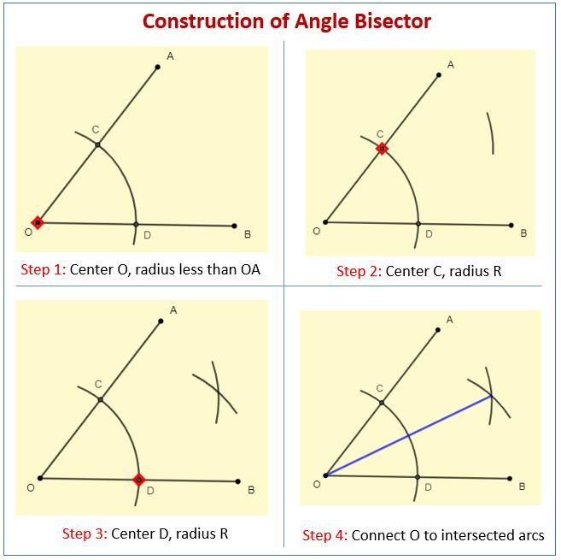
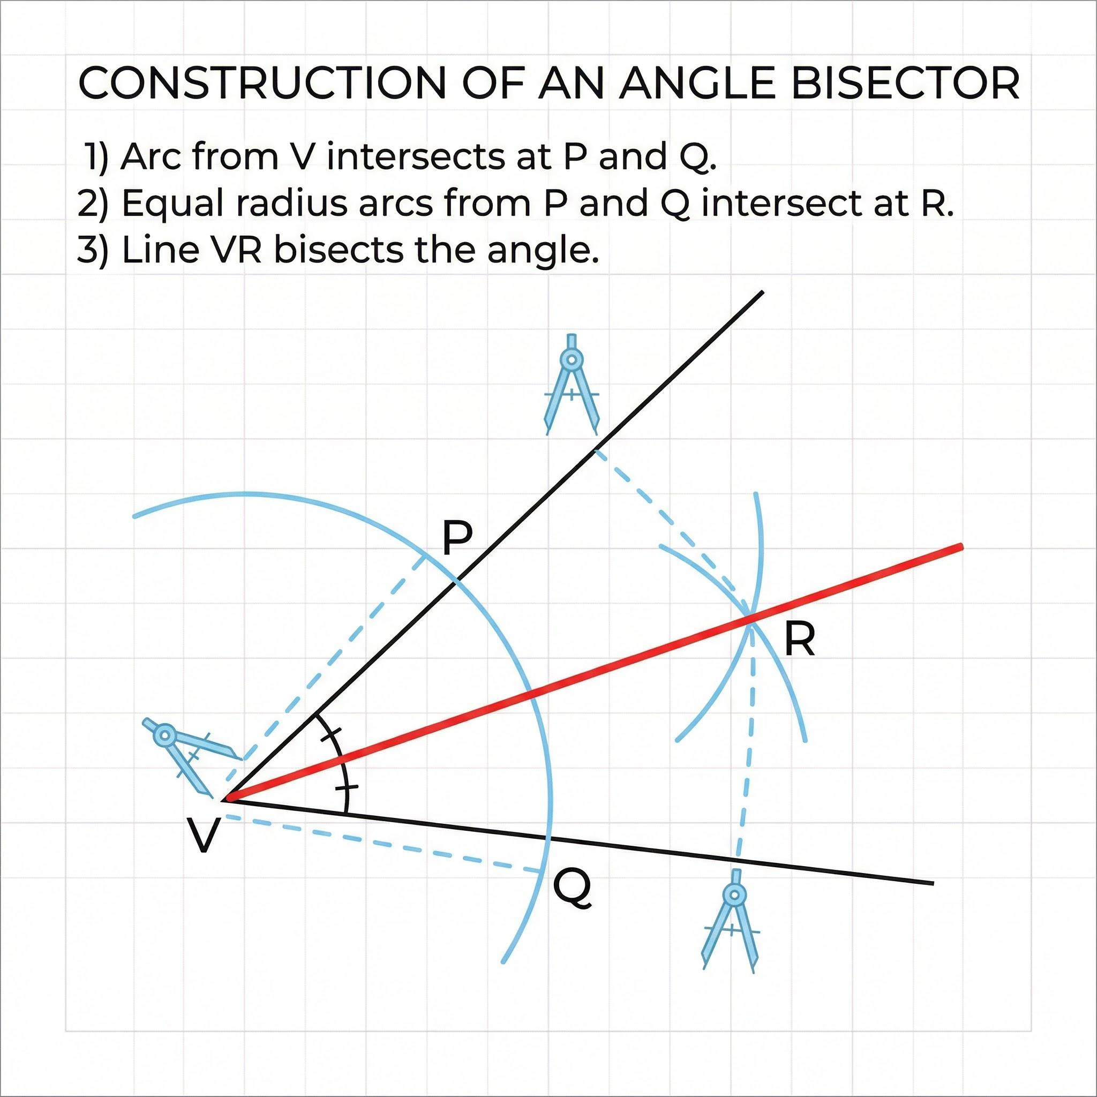
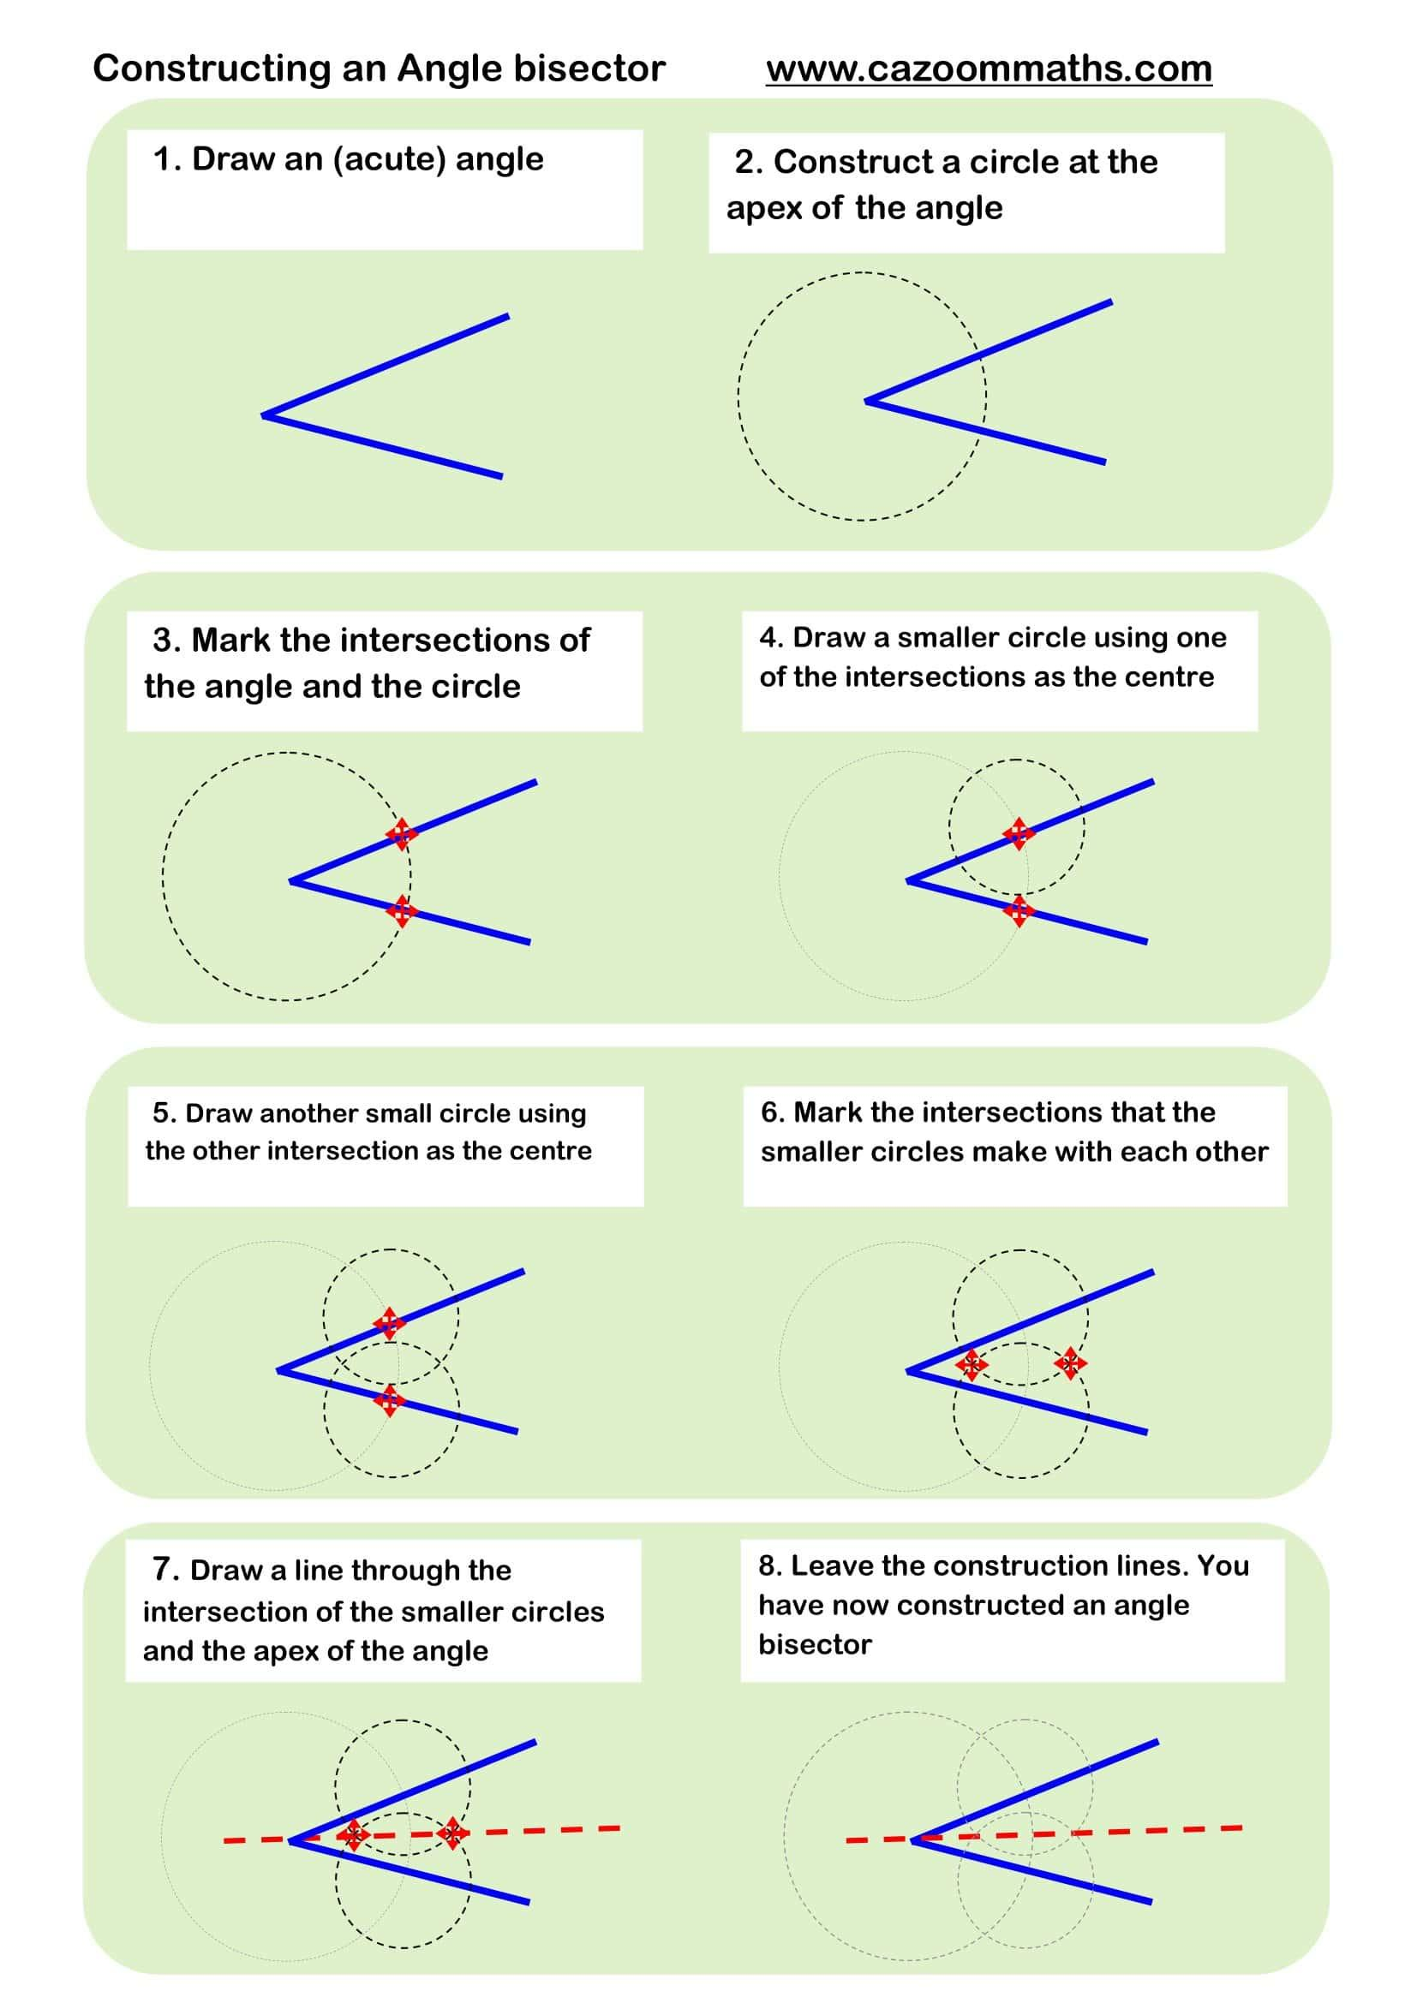
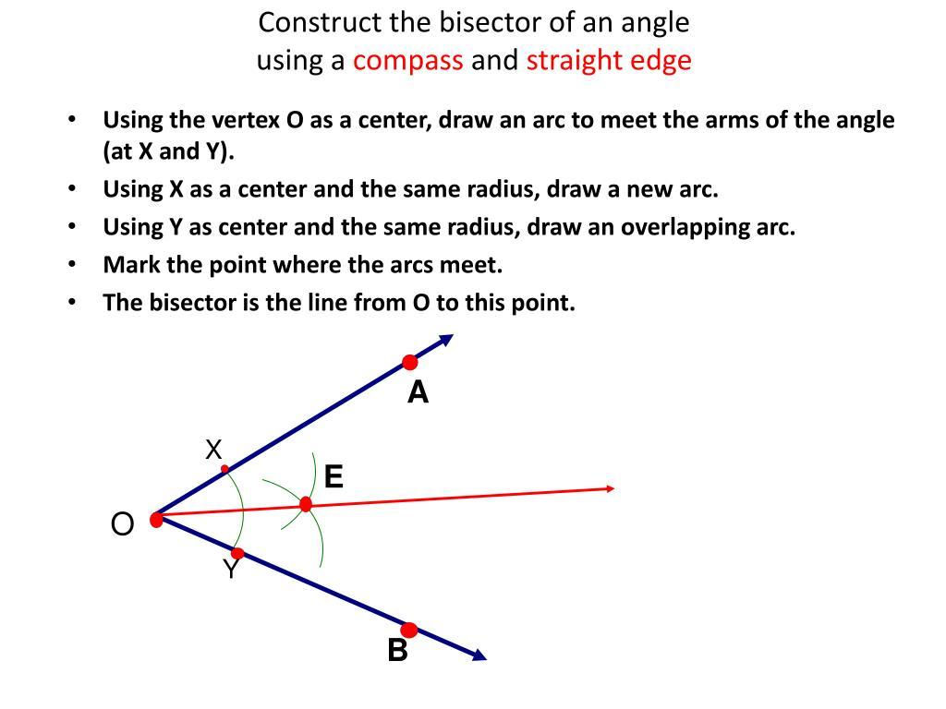
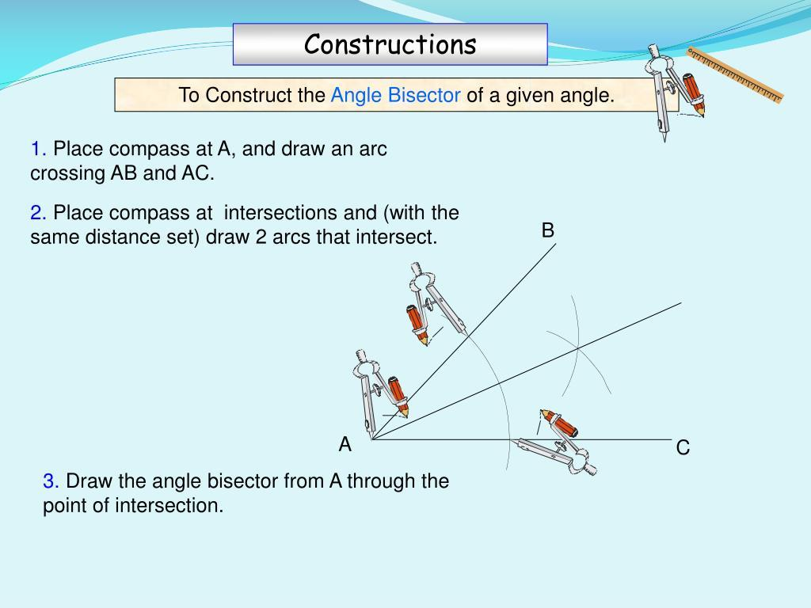

Main Characteristics
# Source: AI Source: Provided by: [Data Path: Persons Table -> ID Column: 1, Name_En Column: Motasem Essam] -> From: [ChatGPT] on [7/25/2026]
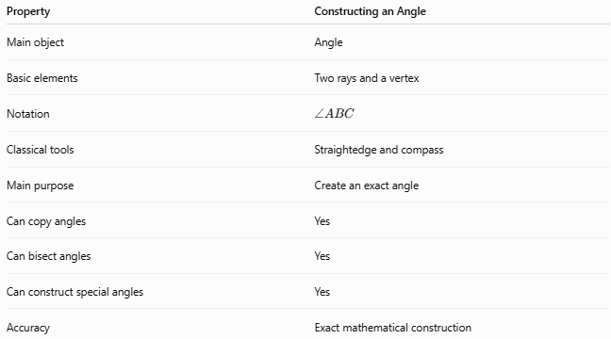
Property | Constructing an Angle
Main object | Angle
Basic elements | Two rays and a vertex
Notation | $$∠ABC$$
Classical tools | Straightedge and compass
Main purpose | Create an exact angle
Can copy angles | Yes
Can bisect angles | Yes
Can construct special angles | Yes
Accuracy | Exact mathematical construction

Important Distinction: Constructing vs Measuring an Angle
# Source: AI Source: Provided by: [Data Path: Persons Table -> ID Column: 1, Name_En Column: Motasem Essam] -> From: [ChatGPT] on [7/25/2026]
Constructing an angle means creating an angle with a required geometric measure.
Measuring an angle means determining the measure of an existing angle.
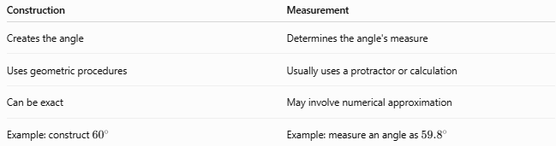
Construction | Measurement
Creates the angle | Determines the angle's measure
Uses geometric procedures | Usually uses a protractor or calculation
Can be exact | May involve numerical approximation
Example: construct ${60}^{∘}$ | Example: measure an angle as ${59.8}^{∘}$
Therefore, drawing an angle that merely looks like ${60}^{∘}$is not a classical geometric construction.

Relationship to Other Constructions
# Source: AI Source: Provided by: [Data Path: Persons Table -> ID Column: 1, Name_En Column: Motasem Essam] -> From: [ChatGPT] on [7/25/2026]
Constructing an angle is closely connected with several other basic constructions.
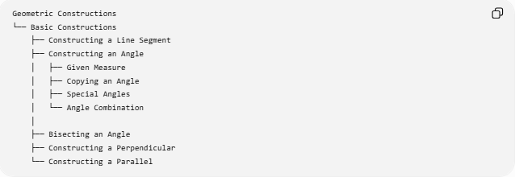
Geometric Constructions
└── Basic Constructions
├── Constructing a Line Segment
├── Constructing an Angle
│ ├── Given Measure
│ ├── Copying an Angle
│ ├── Special Angles
│ └── Angle Combination
│
├── Bisecting an Angle
├── Constructing a Perpendicular
└── Constructing a Parallel
Angle construction is also used in constructing:
- Triangles
- Regular polygons
- Parallel lines
- Perpendicular lines
- Angle bisectors
- Tangents
- Circumcircles
- Incircles

Common Constructed Angles
# Source: AI Source: Provided by: [Data Path: Persons Table -> ID Column: 1, Name_En Column: Motasem Essam] -> From: [ChatGPT] on [7/25/2026]
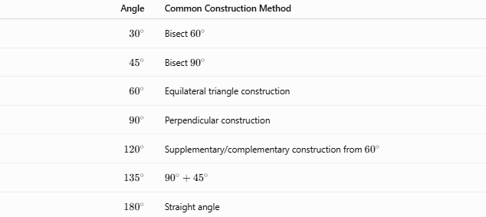
Angle | Common Construction Method
$${30}^{∘}$$ | Bisect ${60}^{∘}$
$${45}^{∘}$$ | Bisect ${90}^{∘}$
$${60}^{∘}$$ | Equilateral triangle construction
$${90}^{∘}$$ | Perpendicular construction
$${120}^{∘}$$ | Supplementary/complementary construction from ${60}^{∘}$
$${135}^{∘}$$ | $${90}^{∘}+{45}^{∘}$$
$${180}^{∘}$$ | Straight angle

Classification
# Source: AI Source: Provided by: [Data Path: Persons Table -> ID Column: 1, Name_En Column: Motasem Essam] -> From: [ChatGPT] on [7/25/2026]
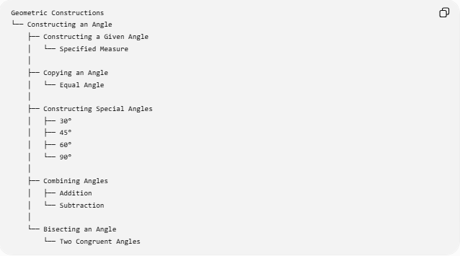
Geometric Constructions
└── Constructing an Angle
├── Constructing a Given Angle
│ └── Specified Measure
│
├── Copying an Angle
│ └── Equal Angle
│
├── Constructing Special Angles
│ ├── 30°
│ ├── 45°
│ ├── 60°
│ └── 90°
│
├── Combining Angles
│ ├── Addition
│ └── Subtraction
│
└── Bisecting an Angle
└── Two Congruent Angles

Key Formulas and Relationships
# Source: AI Source: Provided by: [Data Path: Persons Table -> ID Column: 1, Name_En Column: Motasem Essam] -> From: [ChatGPT] on [7/25/2026]
For an angle:
$$\boxed{∠ABC}$$
Angle Copying
$$\boxed{∠ABC=∠DEF}$$
Angle Bisecting
$$\boxed{∠ABD=∠DBC}$$
Therefore:
$$\boxed{∠ABC=2∠ABD}$$
Complementary Angles
$$\boxed{α+β={90}^{∘}}$$
Supplementary Angles
$$\boxed{α+β={180}^{∘}}$$
Angle Construction by Bisection
$$\boxed{θ_{\text{new}}=\frac{θ_{\text{original}}}{2}}$$

Classification Summary
# Source: AI Source: Provided by: [Data Path: Persons Table -> ID Column: 1, Name_En Column: Motasem Essam] -> From: [ChatGPT] on [7/25/2026]
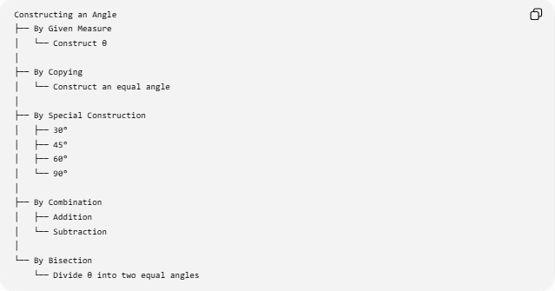
Constructing an Angle
├── By Given Measure
│ └── Construct θ
│
├── By Copying
│ └── Construct an equal angle
│
├── By Special Construction
│ ├── 30°
│ ├── 45°
│ ├── 60°
│ └── 90°
│
├── By Combination
│ ├── Addition
│ └── Subtraction
│
└── By Bisection
└── Divide θ into two equal angles

Key Points
# Source: AI Source: Provided by: [Data Path: Persons Table -> ID Column: 1, Name_En Column: Motasem Essam] -> From: [ChatGPT] on [7/25/2026]
- An angle consists of two rays sharing a common vertex.
- Classical angle construction uses a straightedge and compass.
- An angle can be constructed from a specified measure.
- A given angle can be copied exactly.
- Special angles such as ${30}^{∘}$, ${45}^{∘}$, ${60}^{∘}$, and ${90}^{∘}$have standard constructions.
- An angle can be divided into two equal angles using an angle bisector.
- Constructing an angle is different from measuring an angle.
- Angle construction is fundamental to constructing triangles, polygons, perpendiculars, parallels, and many other geometric objects.

Conclusion
# Source: AI Source: Provided by: [Data Path: Persons Table -> ID Column: 1, Name_En Column: Motasem Essam] -> From: [ChatGPT] on [7/25/2026]
Constructing an Angle is a fundamental type of geometric construction used to create an exact angle or reproduce an existing angle. Using a straightedge and compass, angles can be copied, bisected, combined, and used to construct important special angles.
The central idea is:
$$\boxed{\text{Constructing an Angle}=\text{Creating an exact angle using geometric construction procedures}}$$

